YCAP Board of Directors  John Siwiec, President  Perley-Robertson, Hill & McDougall, Ottawa  Sarah McEachern, Vice-President Education and Events, BLG, Vancouver  Alexandra Mitretodis, Vice-President Technology  Fasken, Vancouver  Jessica Crow, Secretary  Vinson & Elkins, London  Joanne Luu, Treasurer  Burnet, Duckworth & Palmer LLP, Calgary  Michelle Chai  Stewart McKelvey LLP, Halifax  Frédéric Côté  BCF LLP, Montreal  Martin Doe  Permanent Court of Arbitration, The Hague  Christina Doria  Baker & McKenzie LLP, Toronto  Alison FitzGerald  Norton Rose Fulbright LLP, Ottawa  Lauren Harper  Osler, Hoskin & Harcourt LLP, Toronto  Marek Krasula  ICC/SICANA Inc., New York  Carlos Sayo  Davies Ward Phillips & Vineberg LLP, Toronto  Heather Squires  Global Affairs Canada, Ottawa  Genna Woods  Stikeman Elliott LLP, Toronto  YCAP Advisory Board  Lev Alexeev  Pomerleau, Montreal  Cristina Birks  Borden Ladner Gervais LLP, Montreal  Joseph Chedrawe  Vinson & Elkins, Dubai  Tina Cicchetti  Cicchetti Arbitration Law Corp., Vancouver  Stephanie Cohen  Independent Arbitrator, New York  Mark A. Luz  Global Affairs Canada, Ottawa  Eric Morgan  Osler, Hoskin & Harcourt LLP, Toronto  Romeo Rojas  Bennett Jones LLP, Calgary  YCAP Law Firm Sponsors  Borden Ladner Gervais LLP  Davies Ward Phillips & Vineberg LLP  Fasken Martineau DuMoulin LLP  Freshfields Bruckhaus Deringer LLP  Norton Rose Fulbright LLP  Osler, Hoskin & Harcourt LLP  Stewart McKelvey LLP  Stikeman Elliott LLP  White & Case LLP  YCAP Corporate Sponsors  Arbitration Place  FTI Consulting, Inc. |  |  | YCAP 2018 FALL SYMPOSIUM  in conjunction with ICC YAF  Topic: Parallel Proceedings and Transparency in Investor-State Arbitrations  Thursday, 8 November 2018  1:00 pm EST | Registration  1:30 - 4:30 pm EST | Symposium Presentation  4:30 - 6:30 pm EST | Cocktail Reception  Also available via Webcast  Arbitration Place  Suite 940, World Exchange Plaza, 100 Queen St.  Ottawa, Ontario  SPEAKERS:  Key Note Speaker:  Lucy Greenwood, Arbitrator – Greenwood Arbitration (London)  Panel #1: Parallel Proceedings  Alison FitzGerald, Counsel - Norton Rose Fulbright (Ottawa)  Michael Kotrly, Senior Associate - Freshfields (London)  Hugh Meighen, Senior Associate - BLG (Toronto)  Margaret Clare Ryan, Senior Associate - Shearman & Sterling (London)  Panel #2: Transparency  Stephanie Forrest, Associate - Wilmer Hale (London)  Heather Squires, Counsel - Global Affairs Canada (Ottawa)  Elizabeth Whitsitt, Professor - University of Calgary (Calgary)  __________________________________________  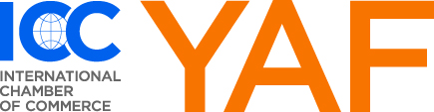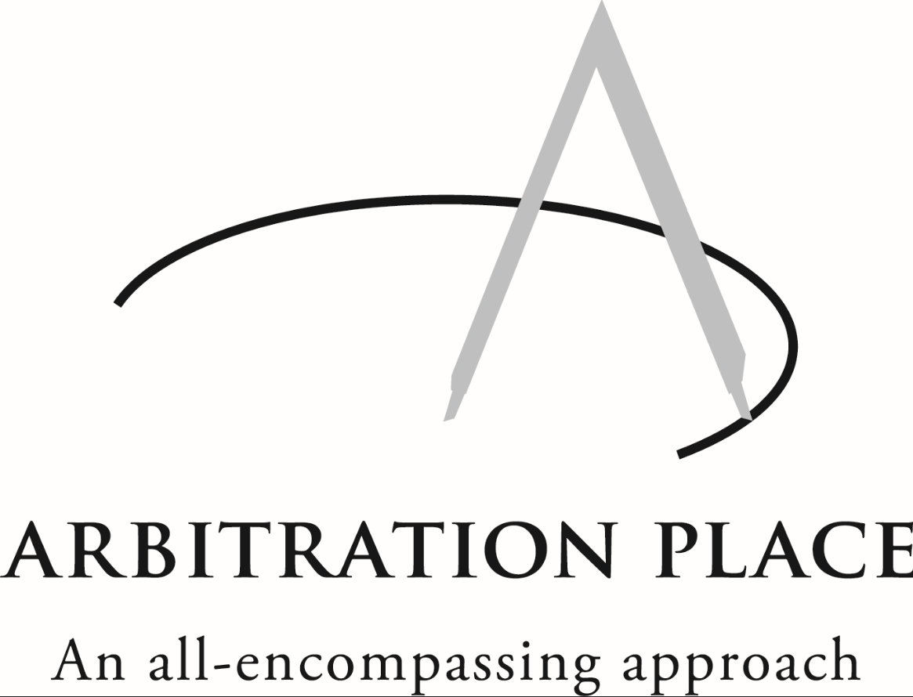
About YCAP
YCAP was launched by a group of young Canadian arbitration practitioners in 2004. The mission of YCAP is as follows:
- to promote interest in and understanding of international arbitration, particularly in Canada, among young lawyers working in private practice and with corporations and government, as well as among other interested young professionals;
- to provide professional development opportunities and a forum for the exchange of ideas for young lawyers and other young professionals with an interest in international arbitration; and
- to provide professional networking opportunities for young lawyers and other young professionals with an interest in international arbitration.
Registration for the YCAP 2018 Fall Symposium
In order to register for the YCAP 2018 Fall Symposium, please complete and return the Registration Form, together with the applicable fee.
If sending by email, please use the following subject line: “YCAP 2018 Fall Symposium Registration”.
For current YCAP and ICC YAF Members, please note that there is no registration fee or other charge for this event.
For Non-Members, the registration fee is CAD 60.00. A discounted rate of CAD 30.00 is applicable for students. Registration fee for online participation via webcast is CAD 20.00.
In order to encourage membership in YCAP, the registration fee will be waived for all individuals who sign up to be a YCAP member by paying the annual membership fee: Individual Member – CAD 85.00; Individual Student Member – CAD 50.00.
Questions or Further Information
If you have any questions or require any further information regarding the YCAP 2018 Fall Symposium, please email Alexandra Mitretodis at amitretodis@fasken.com, adding “YCAP 2018 Fall Symposium Registration” in the subject line.

With the compliments of the YCAP Board of Directors
YCAP 2018 Fall SYMPOSIUM
REGISTRATION FORM
Please complete and return this Registration Form, together with the applicable fee, by mail or email to:

Alexandra Mitretodis
Fasken, 2900-550 Burrard St.
Vancouver, BC, V7X 1T2
Phone: 604-631-3211
Email: amitretodis@fasken.com

Participant ’s Contact Information
Family Name: First Name:
Firm:
Address:

Telephone: Email:
For YCAP/ICC YAF Members:
      - My membership is current and I wish to attend the YCAP 2018 Fall Symposium at no cost.
      - I wish to renew my YCAP membership (fee enclosed) and to attend the YCAP 2018 Fall Symposium at no cost.
      - In person
      - via webcast
For Non-Members:
      - I am not a member of YCAP/ICC YAF and wish to pay the registration fee for the YCAP 2018 Fall Symposium:
      - Non-Member – CAD 60.00
      - Non-Member Student – CAD 30.00
      - Non-Member via webcast* – CAD 20.00
Option 2: I wish to become a YCAP Member by paying the annual membership fee and attend the YCAP 2018 Fall Symposium at no additional cost:
      - YCAP Individual Member – CAD 85.00 In person via webcast*
      - YCAP Individual Student Member – CAD 50.00 In person via webcast*
*Webcast details will be provided to you via email once you have registered and the details have been finalized
Payment Options:
      - I am enclosing a cheque payable to YCAP – Young Canadian Arbitration Practitioners
      - Please charge my Visa/MasterCard/AMEX (Circle one)

Card Number: |  |  |  |  |  |  | Expiry Date:
Name as it appears on the card:
Date: |  |  |  |  | Signature:

